``


Student Name……………………………………

FURTHER MATHEMATICS

WRITTEN TRIAL EXAMINATION 2

2015

Reading Time: 15 minutes
Writing time: 1 hour 30 minutes

Instructions to students
This exam consists of a Core and six modules.
The Core contains a set of extended answer questions from the core, 'Data Analysis'.
The Core is compulsory and is worth 15 marks.
The six modules each contain a set of extended answer questions and begin on page 7.
You should choose 3 of these 6 modules and answer every question in each of your chosen modules. Each of the modules is worth 15 marks.
The three modules you choose are worth a total of 45 marks.
There is a total of 60 marks available for this exam.
The marks allocated to each of the questions are indicated throughout.
Unless otherwise stated the diagrams in this exam are not drawn to scale.
Students may bring one bound reference into the exam.
Students may bring into the exam one approved graphics calculator or approved CAS calculator or CAS software and, if desired, one scientific calculator. Calculator memory does not need to be cleared.
Formula sheets can be found on pages 31 and 32 of this exam.

This paper has been prepared independently of the Victorian Curriculum and Assessment Authority to provide additional exam preparation for students. Although references have been reproduced with permission of the Victorian Curriculum and Assessment Authority, the publication is in no way connected with or endorsed by the Victorian Curriculum and Assessment Authority.

© THE HEFFERNAN GROUP 2015

This Trial Exam is licensed on a non transferable basis to the purchasing school. It may be copied by the school which has purchased it. This license does not permit distribution or copying of this Trial Exam by any other party.

Core

This section is compulsory.

Question 1 (3 marks)

Crop yield is the amount of crop, in tonnes, that is produced on one hectare of land. The dot plot below displays the crop yield of 32 farms that grew a certain type of crop in 2013.

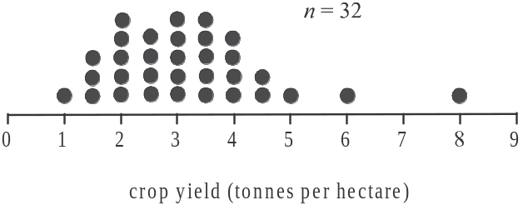

- Find the percentage of farms which had a crop yield of less than 2 tonnes per hectare? 1 mark

- The farm which had a crop yield of 8 tonnes per hectare is an outlier for this group of farms.
Show an appropriate calculation in order to explain why this is the case. 2 marks

Question 2 (5 marks)
The crop yield, in tonnes per hectare, for a particular crop grown on a farm for the period 2003 – 2014, is displayed in the time series plot below.
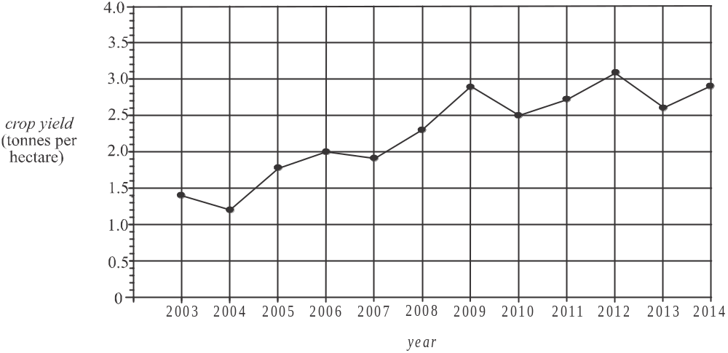

- Which year had the highest crop yield?. 1 mark

A least squares regression line is fitted to the data.

- The equation of this regression line is given by

- According to this regression line what is the crop yield predicted to be in 2020? Express your answer correct to 2 decimal places. 1 mark

- Explain why the predicted crop yield found in part i. is not likely to be reliable. 1 mark

The actual crop yield in 2008 was 2.3 tonnes per hectare.

- Find the residual value, in tonnes per hectare, when the regression line is used to predict the crop yield for 2008. Express your answer correct to two decimal places. 1 mark

- By how many tonnes per hectare does the regression line predict the crop yield will increase each year? Express your answer correct to 2 decimal places. 1 mark

______________________________________________________________
Question 3 (3 marks)

The scatterplot and table below show the crop yield, in tonnes per hectare, and the area, in hectares, over which 18 nearby farms grew this same crop in 2014.

Area  (hectares)  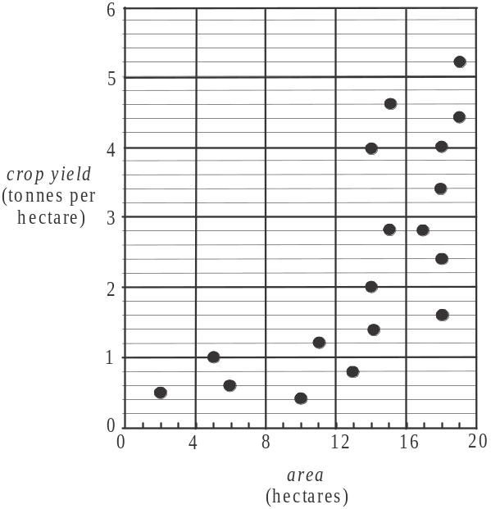 | Crop yield  (tonnes per hectare)
2 | 0.5
5 | 1.0
6 | 0.6
10 | 0.4
11 | 1.2
13 | 0.8
14 | 1.4
14 | 2.0
14 | 4.0
15 | 2.8
15 | 4.6
17 | 2.8
18 | 1.6
18 | 2.4
18 | 3.4
18 | 4.0
19 | 4.4
19 | 5.2

For these 18 farms, the relationship between crop yield and area is not linear.
In an effort to linearise the scatterplot, a reciprocal transformation is to be applied to the variable crop yield.

- By filling in the boxes below, complete the equation of the least squares regression line for this transformed data. Write your answers correct to two decimal places. 1 mark

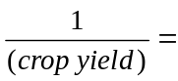 + 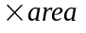

The regression line equation for the transformed data found in part a. enables us to predict the reciprocal of the crop yield from the area of the crop being grown.

- For this transformed data, what is the dependent variable? 1 mark

- Use the regression equation found in part a. to predict the crop yield of a farm which is growing an area of 15 hectares of the crop. Express your answer in tonnes per hectare correct to 2 decimal places. 1 mark

Question 4 (4 marks)

The scatterplot below shows the crop yield, in tonnes per hectare, and the area, in hectares, over which 41 farms have a new type of crop growing.

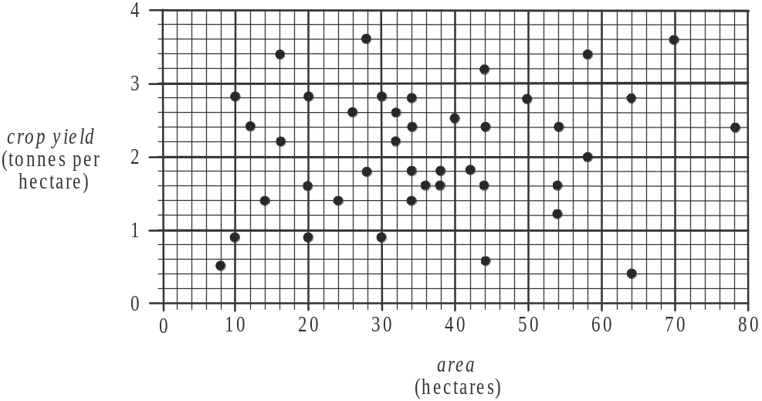

For this data, 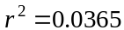.

- Explain why it is not appropriate to find the equation of the least squares regression line for this data. 1 mark

- The mean and the standard deviation of each of the variables crop yield and area are shown in the table below for these 41 farms.

 | crop yield  (tonnes per hectare) | area  (hectares)
Mean | 2.07 | 36.24
Standard deviation | 0.81 | 17.46

  - For one of the 41 farms the crop yield is 0.5 tonnes per hectare.
Find the standard z-score of the crop yield for this particular farm.
Express your answer correct to two decimal places. 1 mark

Assume that the areas over which these farms have the new type of crop growing are approximately normally distributed.

- How many of these 41 farms would be expected to have an area (over which the new type of crop is growing) that is one standard deviation or more below the mean? Write your answer correct to the nearest whole number. 1 mark

- Of these 41 farms, how many actually have an area (over which the new type of crop is growing) that is one standard deviation or more below the mean. 1 mark

Module 1: Number patterns

If you choose this module all questions must be answered.

Question 1 (4 marks)

The graph below shows the number of visitors to a museum each year for four consecutive years.
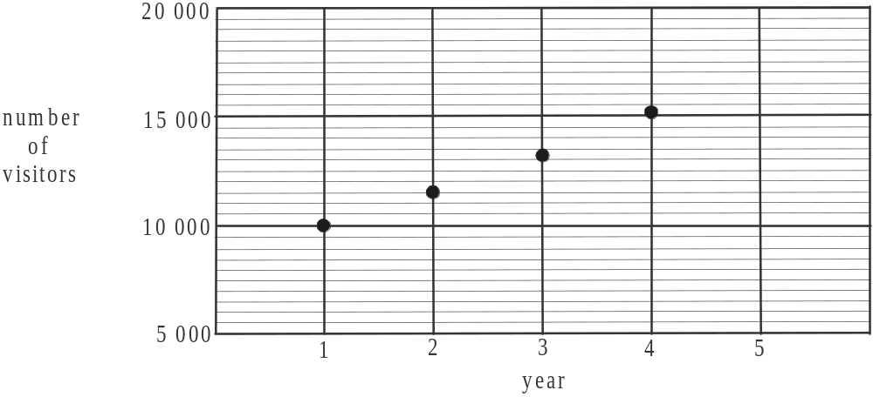

The number of visitors forms the terms of a geometric sequence.

- How many visitors did the museum have in year 1? 1 mark

- Write down a calculation to show that the common ratio for this geometric sequence is 1.15. 1 mark

- On the graph above, plot the number of visitors to the museum in year 5. 1 mark

- Assuming that this pattern of attendance continues, what is the total number of visitors expected to visit the museum for the years 1 to 15? Express your answer to the nearest whole number. 1 mark

Question 2 (5 marks)

The museum opened at the end of 1920. At the end of every year after that, new artefacts were added to the collection. At the end of 1924, there were 340 new artefacts added to the collection. The number of new artefacts, 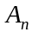, added to the collection at the end of the nth year after the museum opened, is modelled by the difference equation

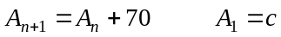.

- i. Find the value of c. 1 mark

  - Explain what 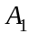 represents. 1 mark

    - Write down the mathematical name given to the sequence generated by the difference equation above. 1 mark

The number of new artefacts added to the collection at the end of the nth year after the museum opened, can be found using the rule 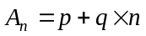, where p and q are both constants and 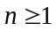.

- Find the values of p and q.
2 marks

Question 3 (6 marks)

Some of the museum’s artefacts are on display and some are held in storage. Artefacts can only be put on display or put in storage at the end of the year. Let 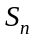 be the number of artefacts held in storage at the end of year n.
The change in the number of artefacts held in storage from one year to the next, is modelled by the difference equation

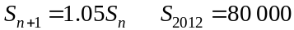.

- Show that the number of artefacts held in storage at the museum at the end of 2014 is 88 200. 1 mark

- The sequence generated by the difference equation shown is geometric. Use this fact and an appropriate formula to confirm that the number of artefacts held in storage at the museum at the end of 2014 is 88 200. 1 mark

At the end of each year the museum lends a fixed number of artefacts (that have been on display) to other museums around the world.

Let 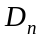 be the number of artefacts on display in the museum at the end of year n.
Let k be the number of artefacts that are lent to other museums at the end of each year.
The change in the number of artefacts on display at the museum from one year to the next can be modelled by the equation

.

- How many artefacts need to be lent to other museums at the end of each year if the number of artefacts on display is to remain constant? 1 mark

There is a limit on how many artefacts the museum can have in storage. That is, the number of artefacts in storage at the end of a given year must not exceed 3 times the number of artefacts on display at the end of the same year.

- Show that if , then the number of artefacts held in storage will exceed the limit at the end of 2014. 1 mark

- What is the maximum number of artefacts that should be lent to other museums at the end of each year so that at the end of 2014 the limit on the number of artefacts held in storage is satisfied? 2 marks

Module 2: Geometry and trigonometry

If you choose this module all questions must be answered.

Question 1 (4 marks)
The base of Phil’s raised vegetable garden is built in the shape of a rectangle with two semi-circular ends. A diagram of this base together with its dimensions is shown below.
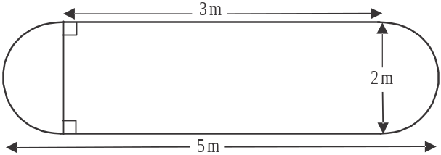

- What is the perimeter of the base of Phil’s garden? Express your answer in metres correct to one decimal place. 1 mark

- What is the area of the base of Phil’s garden? Express your answer in square metres correct to one decimal place. 1 mark

Phil’s vegetable garden is built above the ground and has vertical sides of height 1.2m. Four vertical posts, also of height 1.2m, support the sides.
In the diagram below the vertical sides of the vegetable garden are shaded and the top of the four posts are labelled with A, B, C and D.
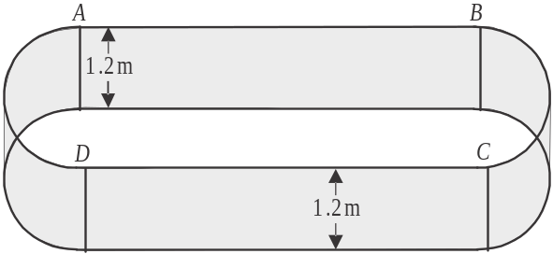

- What is the surface area of the vertical sides of the garden? Express your answer in square metres correct to one decimal place. 1 mark

The garden is to be filled with soil so that it is level with the top of the vertical sides.
- Show that the volume of soil required to fill the garden is 11.0 cubic metres, correct to one decimal place. 1 mark

Question 2 (5 marks)

Before Phil’s vegetable garden structure is filled with soil, a straight metal rod is attached to the top of one of the posts at point A and to the bottom of another one of the posts at point E to give extra stability as shown below.

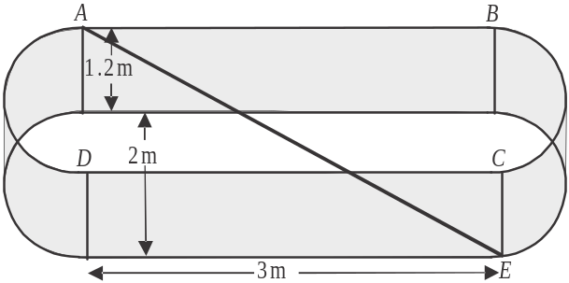

- i. Find the length of this straight metal rod in metres. 2 marks

- Find the angle of elevation of point A from point E. Express your answer in degrees correct to one decimal place. 1 mark

A neighbour wants to build a garden that is similar in shape to Phil’s vegetable garden. He wants the surface area of the soil in his garden to be one and a half times bigger than the surface area of the soil in Phil’s vegetable garden.
The volume of soil in Phil’s vegetable garden is 11 cubic metres.

- What is the volume of soil that the neighbour will need to fill his garden? Express your answer in cubic metres correct to one decimal place. 2 marks

Question 3 (4 marks)

A scarecrow is placed in the garden. It is comprised of a vertical stake to which two triangular sheets of timber have been attached. A spherical ball of radius 10cm sits above this as shown below.
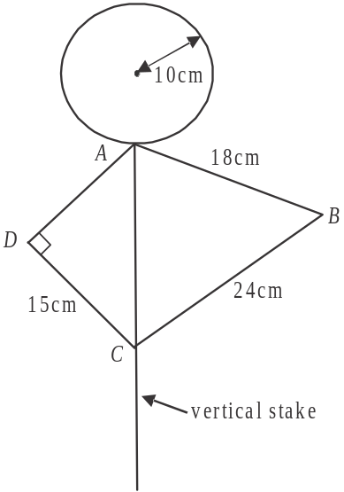

- What is the surface area of the ball? Express your answer correct to the nearest square centimeter. 1 mark

The area of the right-angled triangle ACD, on the left, is 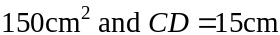.

- Show that . 1 mark

In the triangle ABC, on the right, .

- Find the area of triangle ABC. Express your answer to the nearest square centimetre. 2 marks

Question 4 (2 marks)

A house is located 37 metres from the vegetable garden on a bearing of 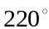.
Also, a shed lies 26 metres due west of the vegetable garden.
Find the bearing of the house from the shed. Express your answer to the nearest degree.

Module 3: Graphs and relations

If you choose this module all questions must be answered.

Question 1 (6 marks)

The business “Killer Cakes” produces a range of cupcakes that they supply to a wholesaler. The revenue R, in dollars, that Killer Cakes receive for supplying n cupcakes is shown by line R on the graph below.
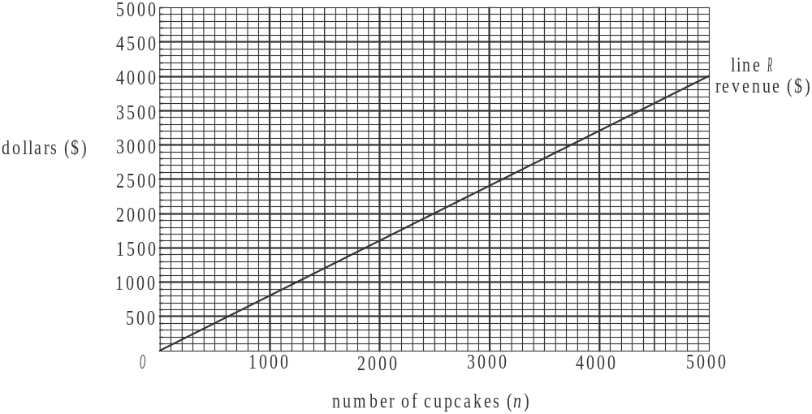

- i. Find the gradient of the line R shown above. 1 mark

- Write down an equation for the revenue, R, in dollars, for supplying n cupcakes. 1 mark

- The cost C, in dollars, of supplying n cupcakes is given by 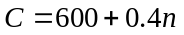. Draw this line on the graph above. 1 mark

- How many cupcakes does Killer Cakes need to supply in order to break even? 1 mark

d. If Killer Cakes supply 2500 cupcakes to the wholesaler, state whether they
make a profit or loss and find the amount of that profit or loss. 2 marks

Question 2 (3 marks)

A retail cake shop also produces and sells cupcakes. The cost of producing each cupcake is $1.50 and the chef produces 120 per day.
Customers can buy the cupcakes individually but they receive a discount for buying four or more and a bigger discount if they buy twelve or more.
The revenue in dollars received by the cake shop for selling n cupcakes is given by

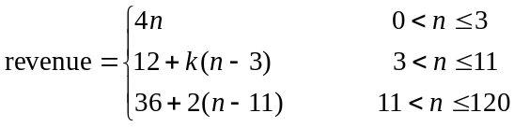

where n is the number of cupcakes a customer purchases in one transaction and k is a constant.

- How much revenue does the cake shop receive if a customer buys 20 cupcakes? 1 mark

- If a customer buys 11 cupcakes the revenue received by the cake shop is $36. Show that . 1 mark

- Find the profit made by the cake shop when a customer buys 30 cupcakes. 1 mark

Question 3 (6 marks)

“Killer Cakes” has a contract to supply a particular supermarket.
Let x be the number of cupcakes they supply to this supermarket each week.
Let y be the number of muffins they supply to this supermarket each week.
The constraints for Killer Cakes are given below.

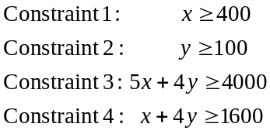

It takes 5 minutes of staff time to produce a cupcake and 4 minutes to produce a muffin.

- Constraint 3 applies to staff time. Explain the meaning of Constraint 3 in terms of the staff time available each week to produce cupcakes and muffins. 1 mark

The lines representing the boundaries of the inequations for Constraints 1, 3 and 4 are shown on the graph below.
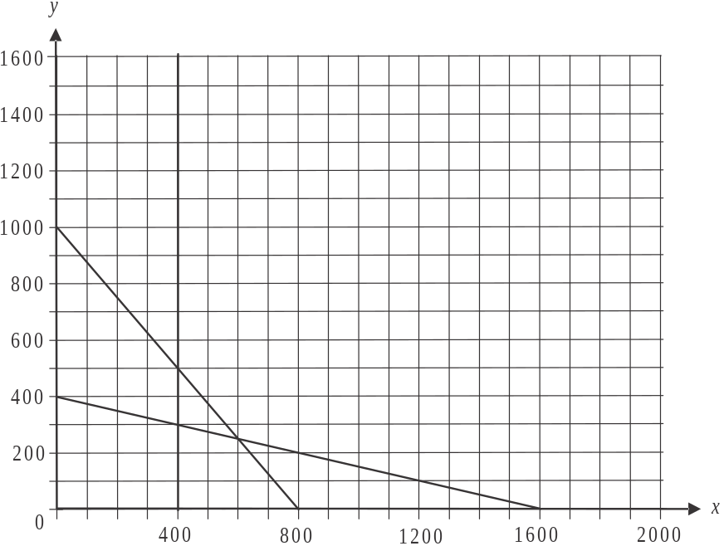

- Draw the line 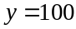 on the graph above. 1 mark

- Shade the region that satisfies constraints 1, 2, 3 and 4 on the graph above. 1 mark

- Find the minimum number of muffins and cupcakes combined, that Killer Cakes must supply each week to this supermarket to satisfy the contract. 1 mark

- If the cost of supplying a cupcake is 40 cents and the cost of supplying a muffin is 25 cents, find the minimum cost per week for Killer Cakes so that they satisfy the contract. 1 mark

One week there is a problem with the production of cupcakes and the maximum number that can be supplied is 400.
Let m be the number of muffins that would need to be supplied in order to satisfy the contract.

- Write down the possible values of m. 1 mark

Module 4: Business-related mathematics

If you choose this module all questions must be answered.

Question 1 (4 marks)

The Parents and Friends Association (PFA) at a school run a barbeque at the start of the school year. The cost of a sausage in bread is $2.

- At the end of the barbeque the PFA reduces the cost to $1.40. What percentage discount of the original cost does this represent? 1 mark

The PFA hired the barbeque for $80 and returned it two days late, therefore incurring a late fee. They were charged simple interest at the rate of 10% of the hire charge for each day it was late.

- What did it cost, in total, for the PFA to hire the barbeque. 1 mark

The treasurer receives the PFA’s bank statement for the month of February 2015 which is shown below. Three entries have been omitted from the statement.

Date | Transaction | Deposit | Withdrawal | Balance
01 Feb 2015 | Opening Balance |  |  | $83 400.00
10 Feb 2015 | Withdrawal |  | $650.00
18 Feb 2015 | Deposit | $380.00 |  | $83 130.00
21 Feb 2015 | Withdrawal |  | $982.40 | $82 147.60
28 Feb 2015 | Interest

- i. Calculate the balance after the withdrawal on 10 Feb 2015. 1 mark

  - The interest on this account is paid at the end of each month and is calculated on the minimum monthly balance at the rate of 2.1% per annum.
What is the interest earned in February 2015? Express your answer to the nearest cent. 1 mark

Question 2 (2 marks)

The PFA has $65 000 in its account from last year’s fete which it wants to invest for six months.
One option is to invest the amount in an account that earns annual interest of 3.6% compounding monthly.

- How much interest will be earned if this option is chosen?
Express your answer to the nearest cent. 1 mark

A second option is to invest in an account earning interest that is compounding weekly. It has been calculated that over a 26 week period this second option will earn the PFA $1711.29 in interest.

- What is the annual interest rate of this second option? Express your answer correct to one decimal place. 1 mark

Question 3 (5 marks)

The PFA wants to invest $30 000 in a perpetuity that will pay an amount of interest each year to the PFA that can be used for new school resources. The interest rate per annum for this perpetuity is 4%.

- What is the amount of interest that would be paid to the PFA each year? 1 mark

____________________________________________________________________

____________________________________________________________________

____________________________________________________________________

- How much money would remain invested in the perpetuity 12 years after its commencement? 1 mark

In order to save this $30 000, the PFA decide to invest $10 000 in an annuity at 3.8% annual interest compounding quarterly. Each quarter, the PFA will add an additional $2 000 to the investment.

- How long will it take for the investment to reach $30 000? Express your answer to the nearest quarter. 1 mark

One year into the investment, the PFA has to reduce the quarterly payment it has been making. The PFA wants to have the $30 000 saved by the end of the fourth year of the investment.

- How much will it now have to pay each quarter? 2 marks

Question 4 (4 marks)

The school has a loan for capital works of $320 000. The interest rate is 4.8% per annum compounding monthly. The school makes repayments of $5000 at the end of each month.

- At the end of the first month into the loan immediately after the first payment is made, the balance of the loan account can be found using the following equation

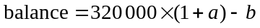.

Write down the values of a and b. 1 mark

- How long will it take to pay off the loan completely? Express your answer to the nearest month. 1 mark

After a certain number of monthly repayments have been made, the balance of the loan is reduced to $105 446.72.

- Find the percentage of the next monthly payment that will be directed to reducing the balance of the loan. Express your answer to the nearest whole percent. 2 marks

Module 5: Networks and decision mathematics

If you choose this module all questions must be answered.

Question 1 (4 marks)

The diagram below shows a network of motorbike tracks connecting the six waterholes that are spread across a cattle station.
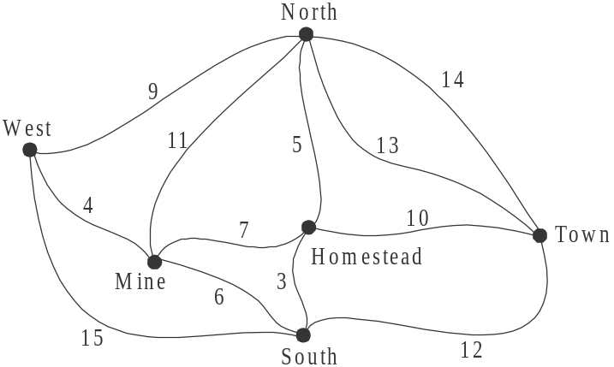

The distances, in kilometers, along the tracks that join the six waterholes, West, Mine, South, Homestead, North and Town are shown.

- What is the degree of the vertex at the Homestead waterhole? 1 mark

- A stockman starts at West waterhole and visits each of the other waterholes once.

- What is the shortest distance he has to travel? 1 mark

- What is the name of the mathematical term that can be used to describe his route? 1 mark

- A second stockman starts at Homestead waterhole and is able to follow an Eulerian circuit. This is possible because the track between two of the waterholes has been closed due to flooding. Write down the name of the two waterholes between which this flooded track lies. 1 mark

Question 2 (4 marks)

During the wet season, four of the staff at the cattle station are given maintenance tasks in four areas around the station. These four areas, together with the time, in days, each of the four staff take to complete the maintenance work there, are shown in the table below.

Area | Jimmy | Frankie | Pete | Lou
stable | 7 | 6 | 5 | 6
shed | 10 | 11 | 9 | 9
office | 4 | 3 | 5 | 6
homestead | 6 | 8 | 7 | 9
Table 1

To minimize the time taken to complete the maintenance in these four areas, the Hungarian algorithm is used to allocate the areas.
This is done by firstly subtracting the smallest number in each of the rows of Table 1 from each of the other numbers in that row.
This has been done in Table 2 below with the exception of the second row.

- Complete Table 2 below by filling in the shaded cells using the Hungarian algorithm. 1 mark

Area | Jimmy | Frankie | Pete | Lou
stable | 2 | 1 | 0 | 1
shed |  |  |  | 0
office | 1 | 0 | 2 | 3
homestead | 0 | 2 | 1 | 3
Table 2

- Explain why it is now possible to allocate the areas. 1 mark

- Complete the bipartite graph below which shows a possible allocation of one area for each worker.
1 mark
Jimmy stable
Frankie shed
Pete office
Lou homestead

- What is the minimum total number of days required to have the maintenance completed in all four areas? 1 mark

Question 3 (7 marks)

A new coolroom is to be built at the homestead. The fourteen activities required to achieve this together with their completion times in days are shown on the network below.
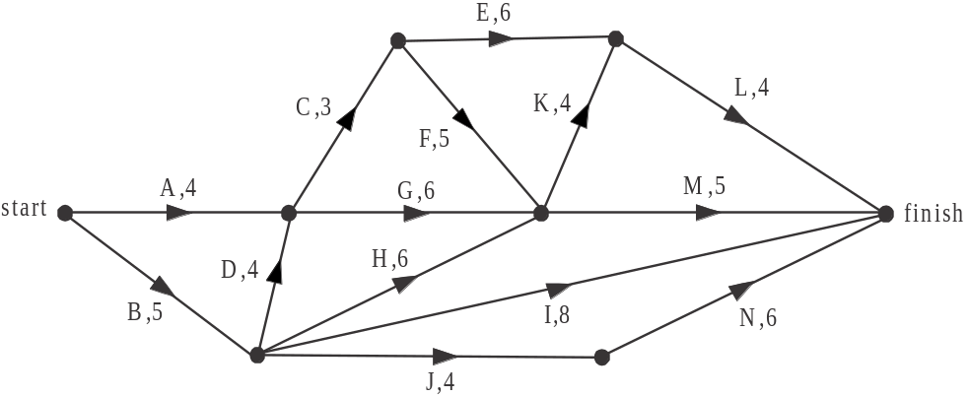

- What is the earliest starting time for activity K? 1 mark

- What is the latest starting time for activity H? 1 mark

- Which activity has the greatest float time? 1 mark

- What is the minimum number of days in which the new coolroom can be built? 1 mark

- One of the activities has a threatened delay of 7 days, which will not affect the minimum completion time of the project.
Which activities could be this one with the threatened delay? 1 mark

Just before construction begins there is an actual delay of 2 days with activity E.

- Which activities lie on the critical path after this actual delay to activity E? 1 mark

After the 2 day delay to activity E occurred, the station owners were given the option of crashing activity K by up to 3 days at a cost of $250 per day.

- What is the least cost of crashing activity K so that the largest reduction in the minimum completion time of the project can be achieved? 1 mark

Module 6: Matrices

If you choose this module all questions must be answered.

Question 1 (6 marks)

In 1996 a charity walk/run fundraiser was started. Entrants could enter one of six different events. The number of entrants in the walking (W) and running (R) events over the five, ten and twenty kilometre courses for that year are shown in the matrix N below.

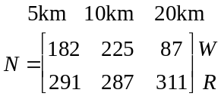

- What is the order of matrix N. 1 mark

- How many entrants were there in the 10km run? 1 mark

- How many entrants were entered in a running event for the fundraiser? 1 mark

In 1996, the cost in dollars of entering a 5km, 10km or 20km event is shown by matrix C below.
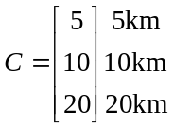

- Explain why the matrix product CN is not defined. 1 mark

- Find matrix P where . 1 mark

- Explain what the element in the second row of matrix P represents. 1 mark

Question 2 (5 marks)

In 2001 a company who sponsored the charity fundraiser also guaranteed that 500 of its employees would enter one of the three running events each year. Over the years the preferences of these employees for a particular running event were analysed. The transition diagram below shows the percentage of employees who are likely to change from one event to anther from one year to the next.

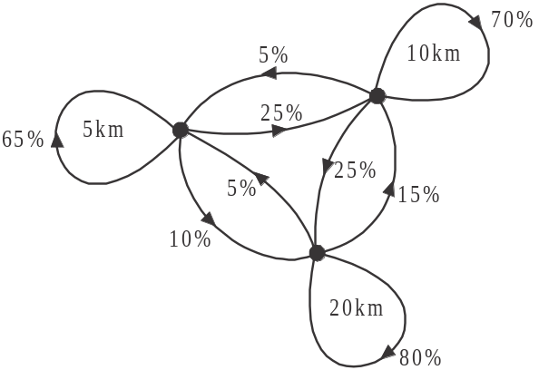

- Of those employees who entered the 10km run one year, what percentage are expected to enter a different running event next year? 1 mark

- Consider those employees who entered the 20km event one year, but changed their event the next year. Of these employees, what percentage changed to the 5km event? 1 mark

The state matrix 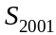 that gives the number of employees who entered the 5km, 10km and 20km running events in 2001 is given below.

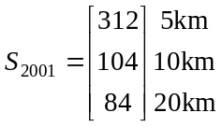

- How many employees changed from the 10km run in 2001 to the 20km run in 2002? 1 mark

The transition diagram given previously can also be represented in matrix form. The transition matrix T that does this is given by

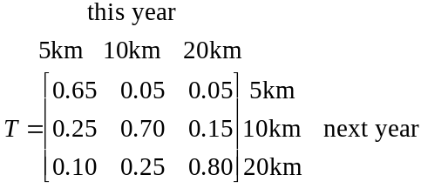

The matrix equation 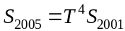 gives us the state matrix for 2005; that is, the number of employees who in that year entered the 5km, 10km or 20km running event.

- Find the number of employees who entered the 5km event in 2005. Express your answer to the nearest whole number. 1 mark

- Write down a matrix equation that gives the state matrix for 2008. 1 mark

Question 3 (4 marks)

For the years 2001 to 2008, the transition matrix T that shows the percentage of employees expected to change their event from one year to the next from Question 2, is given by

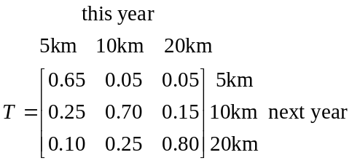

In 2009, the 20km running event could not be staged.
For 2009 only, the transition matrix 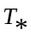 that shows the percentage of employees expected to change their event from 2008 to 2009 is given by

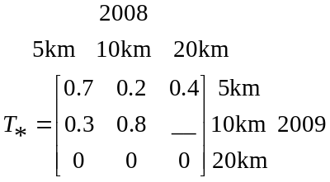

- Complete the 2009 transition matrix 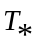 by filling in the missing entry. 1 mark

- There was a group of employees who ran the 10km event in 2008 and were expected to run the 20km event in 2009 had it been staged.
What percentage of this group were expected to enter the 5km event instead? 1 mark

- Find the number of employees who were expected to enter the 10km event in 2009.
Express your answer to the nearest whole number. 2 marks

Further Mathematics Formulas

Core: Data analysis

standardised score: 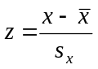
least squares line: 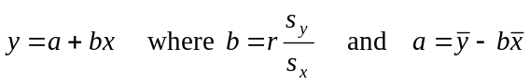
residual value: residual value = actual value – predicted value

seasonal index: seasonal index 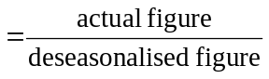

Module 1: Number patterns

arithmetic series: 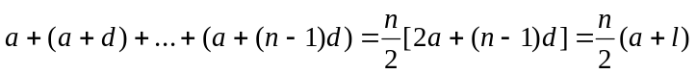
geometric series: 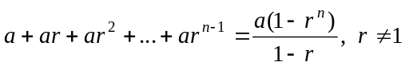
infinite geometric series: 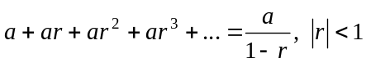

Module 2: Geometry and trigonometry

area of a triangle: 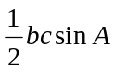
Heron's formula: 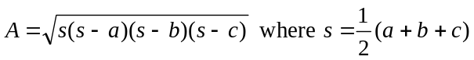
circumference of a circle: 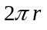

area of a circle: 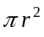

volume of a sphere: 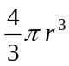
surface area of a sphere: 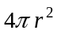

volume of a cone: 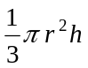
volume of a cylinder: 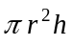

volume of a prism: 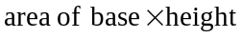
volume of a pyramid: 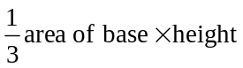

Mathematics Formula Sheets reproduced by permission; © VCAA 2014. The VCAA does not endorse or make any warranties regarding this study resource. Current and past VCAA VCE® exams and related content can be accessed directly at www.vcaa.vic.edu.au
Pythagoras’ theorem 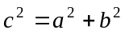

sine rule: 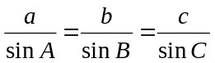
cosine rule: 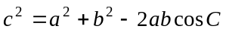

Module 3: Graphs and relations

Straight line graphs
gradient (slope): 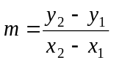
equation: 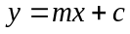

Module 4: Business-related mathematics

simple interest: 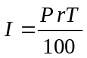
compound interest: 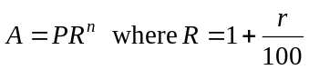
hire purchase: 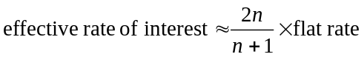

Module 5: Networks and decision mathematics

Euler’s formula: 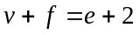

Module 6: Matrices

determinant of a 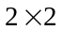 matrix 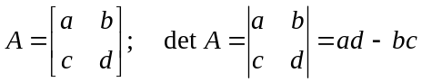
inverse of a matrix 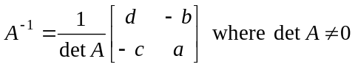

END OF FORMULA SHEET

